**Draft D5 project page text, live July 17**

**I-71 Widening to Six Lanes from Downtown to I-265**

KYTC has two current projects in the design phase to widen I-71 in Jefferson Co. The purpose of these adjacent projects is to reduce traffic congestion and improve safety along this critical corridor.

* Item No. 5-48.10 is to widen I-71 from Downtown to just north of Zorn Ave.
* Item No. 5-557.00 is to widen I-71 from Zorn Avenue to I-265.

Included with Item 5-48.10 are alternatives at Zorn Avenue (Exit 2) to improve traffic operations and safety at the interchange with I-71.

Included with Item 5-557.00 is a study of the key I-71/I-264 interchange (Exit 5) in an effort to improve traffic operations and safety as well as promote reliability of the regional interstate system.

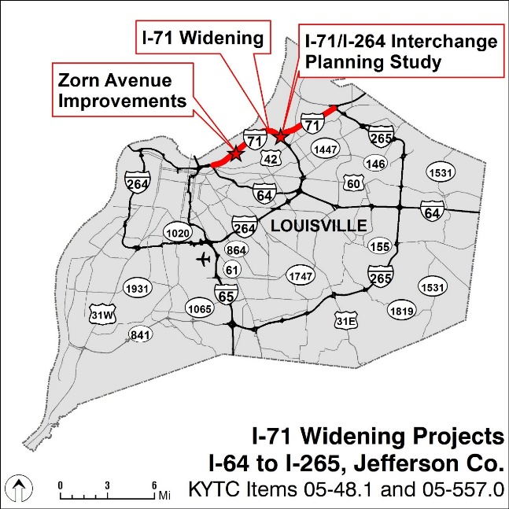

An interactive website has been developed (<https://bit.ly/3guJSSF>) to share information about the projects and study processes to date and give some details on the alternatives and improvement concepts developed.

KYTC is also seeking community input on the proposed projects. Please review the website then take a quick survey (<https://www.surveymonkey.com/r/GDM5WY5>) to share your opinions. Responses will be collected through August 16, 2020.